Alexander Baldree
04/24/26
Module 6.2 Assignment
CSD420

GitHub Link:
https://github.com/Panda-Alex21687/CSD420

Clean Test:
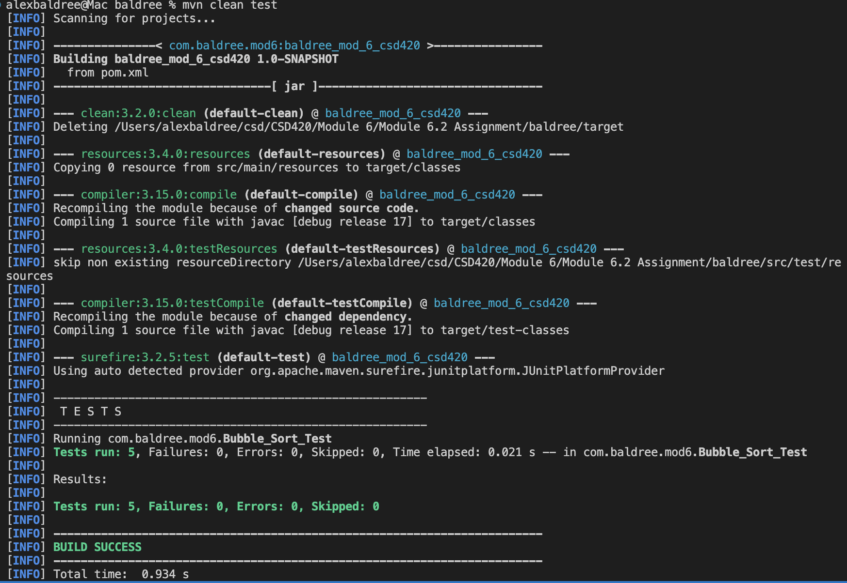

MAVEN Library setup:
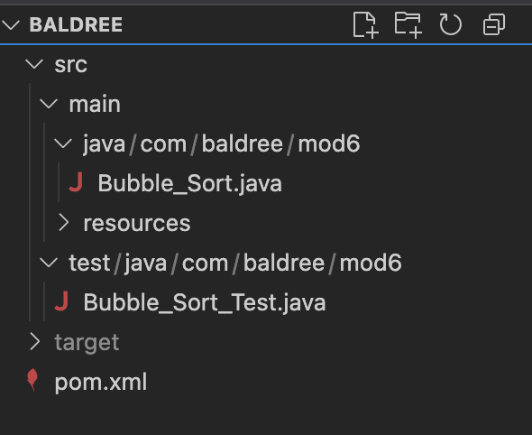

Installed Correctly:
